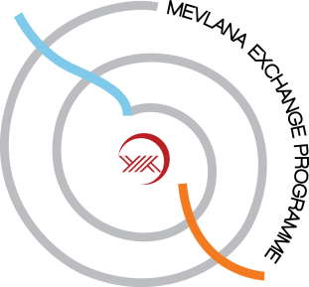

........................... UNIVERSITY

MEVLANA STUDENT DECLARATION

As a Mevlana exchange student, you have the right to expect:

- Your home and host university to have an agreement of Mevlana Exchange Programme Protocol;
- To sign a Learning Protocol between you and sending/receiving institutions indicating the details of your activities abroad, including the credits to be achieved;
- Not to be obliged to pay fees to your host institution for tuition, registration, examinations and laboratory activities during your exchange period;
- Full academic recognition from both your home university and host university for satisfactorily completed activities during the Mevlana mobility period, with regard to the Learning Protocol;
- To be given a transcript of records signed by host university at the end of your exchange, covering the studies carried out including the credits and grades achieved at your host institution;
- To be treated and served equally by your host university with their home students regarding gender, ethnicity, religion and language;
- Your student grant or loan from your home country to be maintained during the ongoing exchange period;

As a Mevlana exchange student, you are expected to:

- Respect the rules and obligations of your Agreement of Obligations signed with your home university as well as the general rules of Mevlana Exchange Program;
- Ensure that any changes to the Learning Protocol are agreed in writing with both the home and host institutions as soon as they occur;
- Respect the rules and instructions as agreed at the host university, and achieving the required grades including undergoing the relevant examinations or other forms of assessment during your exchange period
- Provide feedback by writing a report on your exchange period abroad when you return at the end of the study.

If you have a problem:

- Check your rights and obligations,
- If you have any problems concerning the exchange programme, at first contact your Mevlana departmental coordinator.

